Checking for Leaks in Your Home

Learn where leaks can commonly found

and how to tell if you have a leak
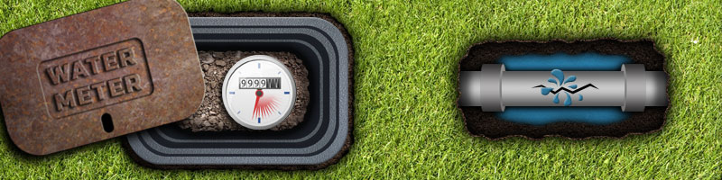
In just one home, leaks in plumbing can waste anywhere from 2,000 to 20,000 gallons every year. They can also cause serious structural damage, mold problems, and in the case of a dripping faucet, insanity. The worst part? Many leaks aren’t even visible and can be difficult to detect. Water stains, or a significant increase in your water bill, could tip you off to their presence. Some leaks are obvious and easily fixed. Some, not so much. What follows are some methods to help you check for leaks in your home, seen and unseen. While not the most exciting way to spend your Saturday, checking for and locating leaks will save a lot of water, and it may save you money - water use will go down, and you won’t need to pay the plumber extra hours to find leaks for you!
Got kids around? Turn your leak detection hunt into a fun, educational game! Teach children about why saving water is important and let them help you try to spot leaks in and around your home. An extra set of eyes is always handy, and they may even see something you miss!

Indoor Leaks

Toilet flappers often leak "silently" but the test & the fix are super easy!
The easiest way to begin is to take a good look at your fixtures and appliances. Toilets are the most common leak culprit and are hard to spot without testing. Leaking flappers in your toilet tank will double your water bill in a month’s time.
To detect a leak with your toilet flapper place 5-10 drops of food coloring in the back tank of your toilet; after adding the coloring, do NOT flush the tank, but instead, wait a little while for the tank water to change color and settle. If after about 10-15 minutes (without flushing the tank) you find the water in the toilet bowl to be the same color as the colored water inside your tank, you'll know you have water escaping from the toilet's tank since that’s the only place you have the colored water. You will need to replace the flapper in your toilet and this will stop the extra water usage.
If you suspect that your toilet flapper is hanging up after the toilet is flushed and this does not occur after each flush your best bet is to replace the entire operating system in your toilet. This is a simple cheap fix that can save you money in the long run.

Even a slow drip can waste hundreds of gallons of water per year
Faucets are notorious leakers. Luckily, these leaks are usually obvious, and a leaking faucet often needs only a replacement part or new o-ring to be fixed, and such repairs are often easy enough to do on your own.

Outdoor Hidden Leaks
Your water meter is a useful tool for finding leaks
Some leaks know how to hide. If you’ve tried everything mentioned above and found nothing, but still have your suspicions that there’s a leak somewhere, there is one more thing to try before calling the plumber. While you may not be able to locate them, you can at least confirm the existence of a larger leak (or several smaller ones) using your water meter.
Make sure that every faucet and water-using appliance in and around your home is off. Keep in mind any automatically-controlled devices like ice makers, pool filters, and pumps, and be sure to disable them. Once you're certain your house shouldn't be drawing any water, take a look at the water meter. Any water or dampness in the meter housing could be sign of a leak: if a source cannot be found on the meter, it could point to a leak on the supply line (water from a leak can travel down the length of a pipe to collect in a completely different area from the leak).
Check for movement of the flow indicator (a smaller dial on the meter face, usually with a large triangle in the center). If it's moving, water is flowing somewhere. If it’s still, you're not safe yet: the leak may be slight. For a more thorough test, record the number displayed on the meter register (the main display recording your home's water use), and come back a minimum of 15 minutes later to see if any water has been used. For more reliable results, you can leave everything off overnight and then check for usage. Remember, though: the bathroom is off-limits during this period!
Should you end up detecting a leak, you can get a better idea of its general location by shutting off the main water supply outside your home. If meter-movement still occurs, you have a leak in the piping going between the meter and the house. No movement? Your leak is somewhere in the house. If your water meter test comes up negative, this does not necessarily mean you're in the clear. Some leaks are only occasionally active, and it could be that your test was performed outside of that window.
The EPA estimates that the average household’s leaks can waste upwards of 10,000 gallons a year. 10% of homes lose 90 gallons or more per day. Collectively, that’s a whole lot of water. With these kinds of figures in mind, checking for and repairing plumbing leaks becomes much more than just preventing damage to your home, or saving a few dollars. Using the tips here, you’ll be contributing to the preservation of our most important resource. Good job!

